**Video Game Rating’s Effect on Sales**

Bowen Cheng (500880144)

**Introduction**

Video gaming content has become more detailed and explicit with the introduction of modern computers and the improvement in technology. Publishers began pushing the boundaries of excessive violence and/or sexual content in games to increase sales for their respective companies. The ESRB (Entertainment Software Rating Board) was formed to help classify and assign age and content ratings on most consumer video games. This was in response to the growing number of complaints surrounding controversial video games.

The main question we put forth is whether games with a higher rating did in fact lead to greater sales numbers. A video game’s popularity also relies upon positive reviews and scores from critics alike. Therefore, we will also do comparative analytics between the two and see which had a greater impact. Techniques used will include data cleaning of missing values, exploratory analysis through association rule mining (genres and developers), clustering (by ratings and different markets), and regression analysis on the findings.

**Literature Review**

To better understand the ESRB rating system, an article explains how this voluntary group determines and enforce the ratings on games. Publishers send in an application to the board along with game footage and examples of potentially offensive content. The raters reach a consensus with a specific rating and then it becomes official. The report later states games rated ‘Mature’ sells slightly better than other games rated lower. [1]

Although M-rated games sell better, it doesn’t necessarily mean that more titles in this category were being produced and released. In 2010, these games only made up of 5% of the total that were given a rating. However, among the top ten best-selling games in the United States five of them were rated ‘Mature’. [2]

How about games with strong reviews? A study shows that games sold on Steam (a digital distribution platform for video games) with better Metacritic review scores will have a higher chance of selling more than ones with lower scores. Nevertheless, the data contained many outliers and the variability in sales performance could be the result of other factors. [3]

The Entertainment Software Association (ESA) conducts business and consumer research on the video game industry in the United States. Their 2015 report on sales and usage data indicates that a product’s ESRB rating only accounted for 2% of factors influencing the decisions on buying video games. In the same breakdown, 3% were affected by the product reviews in magazines and video game websites. [4]

There have been a lot of debate on how effective the ESRB ratings are on video games. Some argue that most games do not reflect the proper ratings. A study showed there were significant differences between the types and degrees of content found within T-rated games compared with E-rated games. They concluded there should be age-based rating symbols within each rating to better explain content as the initial ratings covers too wide a spectrum. [5]

How about the impact of reviews on game purchases? Reviews plays a huge role in getting popularity through ‘word-of-mouth’. However., a direct correlation between game reviews and sales was hard to determine since opinions differ quite a lot based upon the enthusiasm of the reviewer and the targeted gaming audience. A distinction was found on how scores were viewed by casual and hardcore gamers alike. [6]

Another study was done on the impact of player experiences due to negative game reviews and user comments. Their result suggested that reading a positive review does not necessarily provide any benefits in player experience, but if it was well received then it could generate hype which in turn would lead to better sales. The report surmised negative affective text in reviews had a greater overall effect on experience over positive affective text. [7]

**Breakdown of U.S. Computer and Video Game Sales in 2011, by Rating** [8]

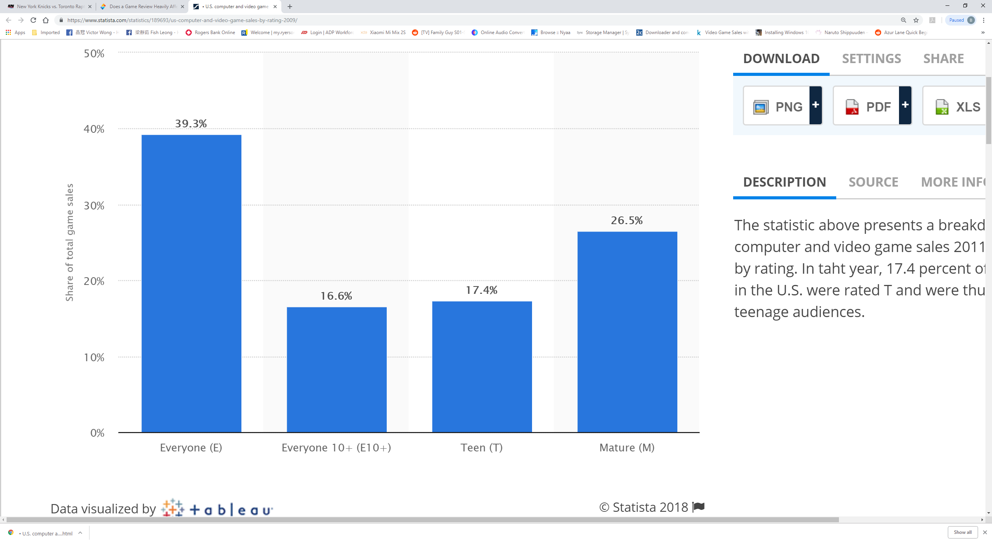

Below is a bar plot generated from our dataset using R on the distribution of games by ratings after cleaning all missing values.

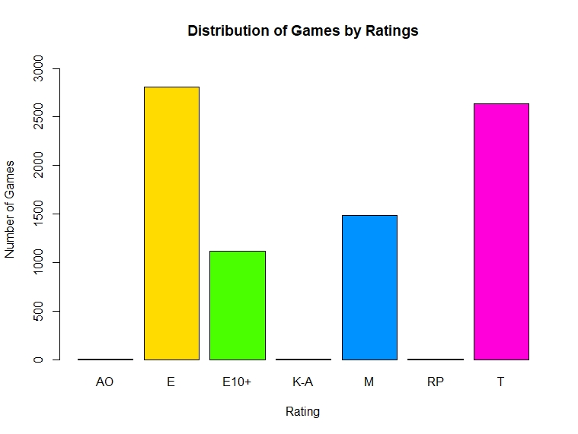

# References:

[1] Ed Grabianowski "How the ESRB Works" 14 September 2005.

<https://electronics.howstuffworks.com/esrb.htm>

[2] Ben Kuchera “GAMING & CULTURE - 2010: 5% of games given M rating, including 29% of big sellers” 21 March 2011.

<https://arstechnica.com/gaming/2011/03/in-2010-5-percent-of-games-were-rated-m/>

[3] Kyle Orland “GAMING & CULTURE - Steam Gauge: Do strong reviews lead to stronger sales on Steam?” 23 April 2014.

<https://arstechnica.com/gaming/2014/04/steam-gauge-do-strong-reviews-lead-to-stronger-sales-on-steam/>

[4] Entertainment Software Association (ESA) “Essential Facts about the Computer and Video Game Industry” 2015 Sales, Demographic and Usage Data

<http://www.theesa.com/wp-content/uploads/2015/04/ESA-Essential-Facts-2015.pdf>

[5] Kevin Haninger, Kimberly M. Thompson, ScD " **Content and Ratings of Teen-Rated Video Games**" 18 February 2004.

<https://jamanetwork.com/journals/jama/fullarticle/198217>

[6] Blog Article from Social App Support, adish Co. Ltd. "**Does a Game Review Heavily Affect Game Purchases?**" 3 September 2018.

<https://socialappsupport.com/en/blog/game-review-affect-game-purchases/>

[7] Ian J. Livingston, Lennart Nacke, Regan L. Mandryk "**The Impact of Negative Game Reviews and User Comments on Player Experience**" August 2011.

<https://www.researchgate.net/publication/228466586_The_Impact_of_Negative_Game_Reviews_and_User_Comments_on_Player_Experience>

[8] Statista: The Statistics Portal," **Breakdown of U.S. computer and video game sales in 2011, by rating**"

<https://www.statista.com/statistics/189693/us-computer-and-video-game-sales-by-rating-2009/>

**Dataset**

A link to the dataset used can be found at <https://www.kaggle.com/rush4ratio/video-game-sales-with-ratings>. This data shows sales information from VGChartz for the past 30 years of video games from all platforms and markets along with their ratings and review scores from critics and users alike.

The following attributes will be used for the analysis: Genre, Publisher, NA_Sales, EU_Sales, JP_Sales, Other_Sales, Global_Sales, Critic_Score, Rating. All sales figures are in millions of units. Other_Sales are game sales made up of the rest of the world (ie. Africa, Asia excluding Japan, Australia, Europe excluding the E.U and South America).

Attributes not used include: Name for the initial analysis though we may look at certain games with highest or lowest values in each category, Platform since our focus is on all games, Year of Release although we may revisit this separately to discover any possible trends, User_Score since bias may exist, but will still be looked at in the analysis for comparison with Critic Score . Critic_Count and User_Count as we are only concerned with the critic score itself, Developer.

**Approach**

Here will be the general guidelines and steps to my analysis:

After cleaning all missing and NA values, we have a total of 8054 games with ratings and critic scores. Below is the breakdown by ratings:

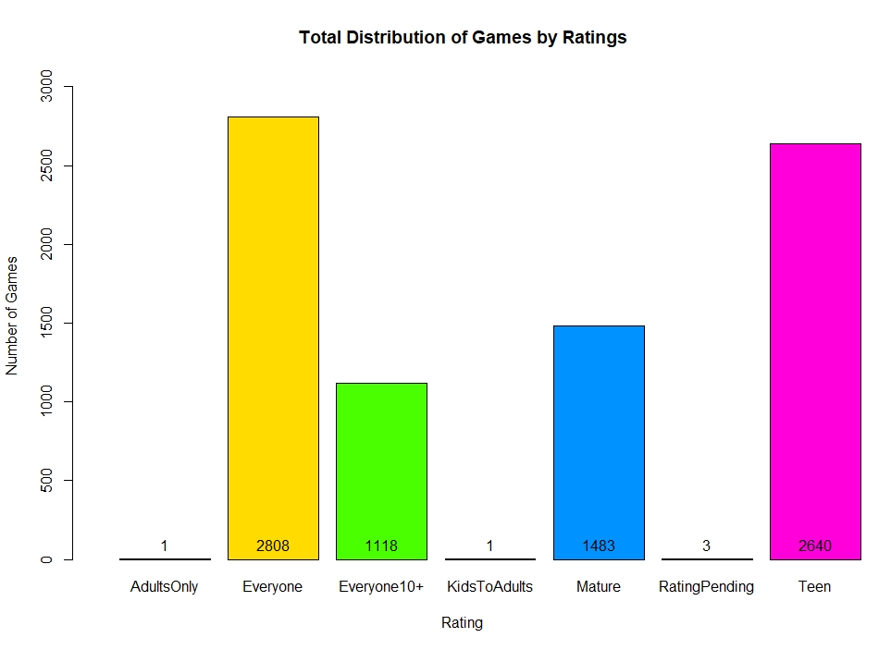

Were there any bias in Critic Scores with respect to the game rating? It appears not as per below.

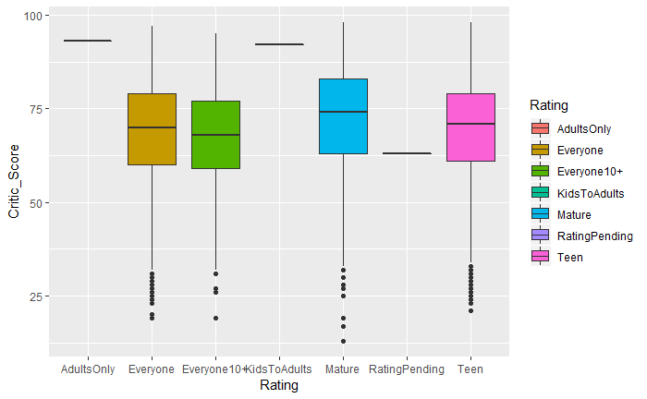

To further illustrate the impact of technology on video games, the below chart shows the percentage in total sales through the years.

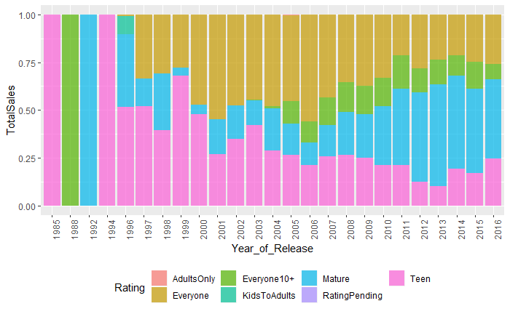

There was an increase in market share with regards to Mature rated games from 2000 onwards, especially in 2013. This was mainly due to best reviewed games like ‘Grand Theft Auto’ and ‘The Last of Us’ as per Metacritic. Below are the top 10 video game publishers and Game Rating breakdown of the Top 4 Publishers.

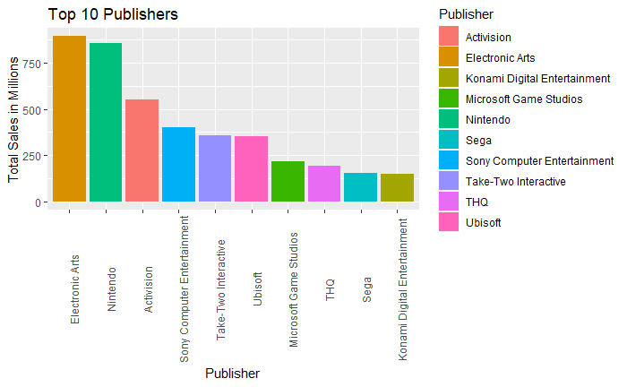

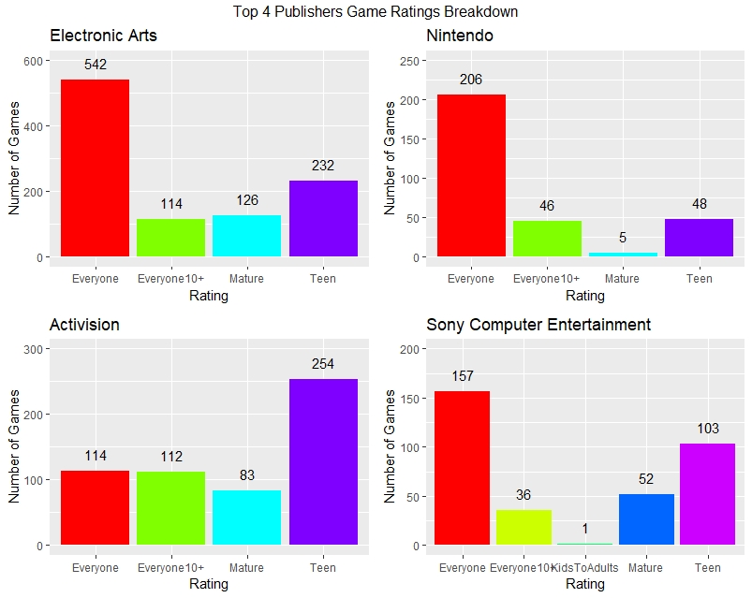

From the charts above, it appears that the top publishers release ‘Everyone’ rated games the most apart from Activision. Here are their sales figures separated by Ratings.

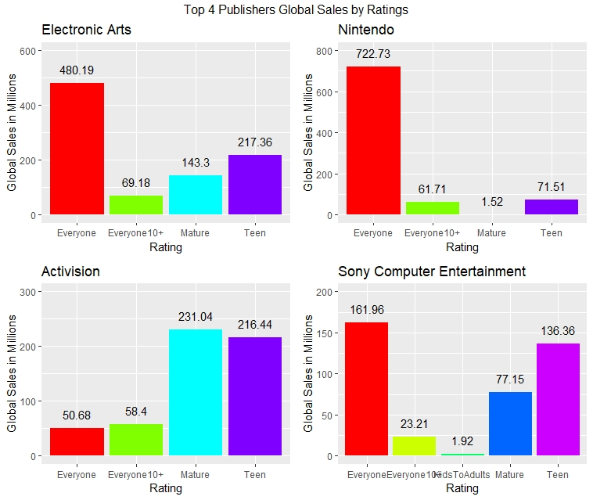

Here is the sales breakdown of games separated into their respective regions. Totals are in millions.

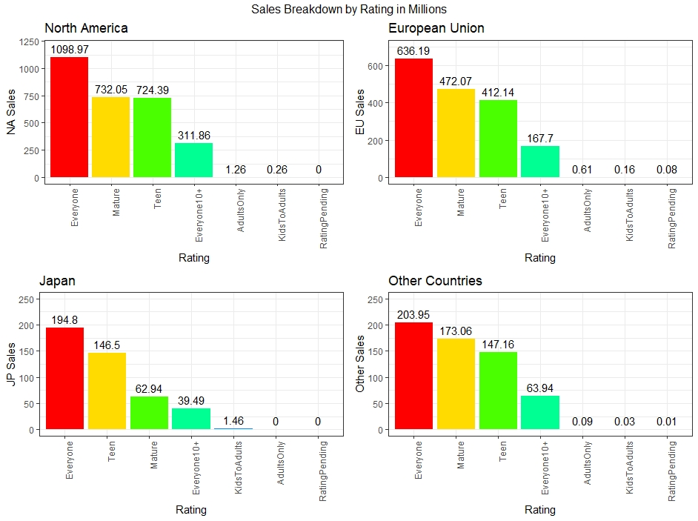

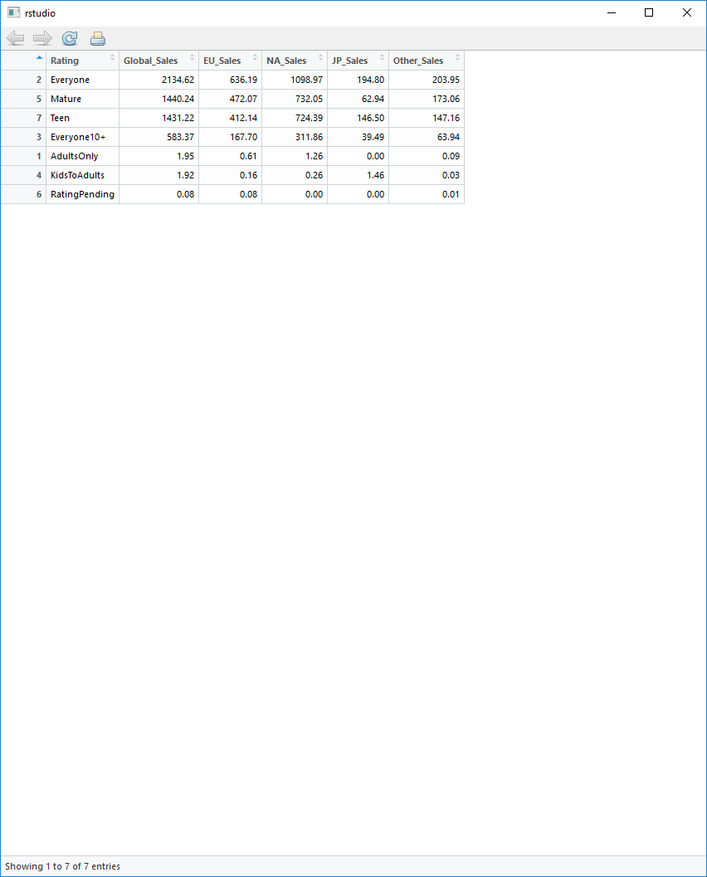

‘Everyone’ rated games seem to sell the most across all regions. In North America, Mature and Teen rated games sold about the same units.

Here is the sum of all sales separated by the different genres and sorted by the total Global Sales.

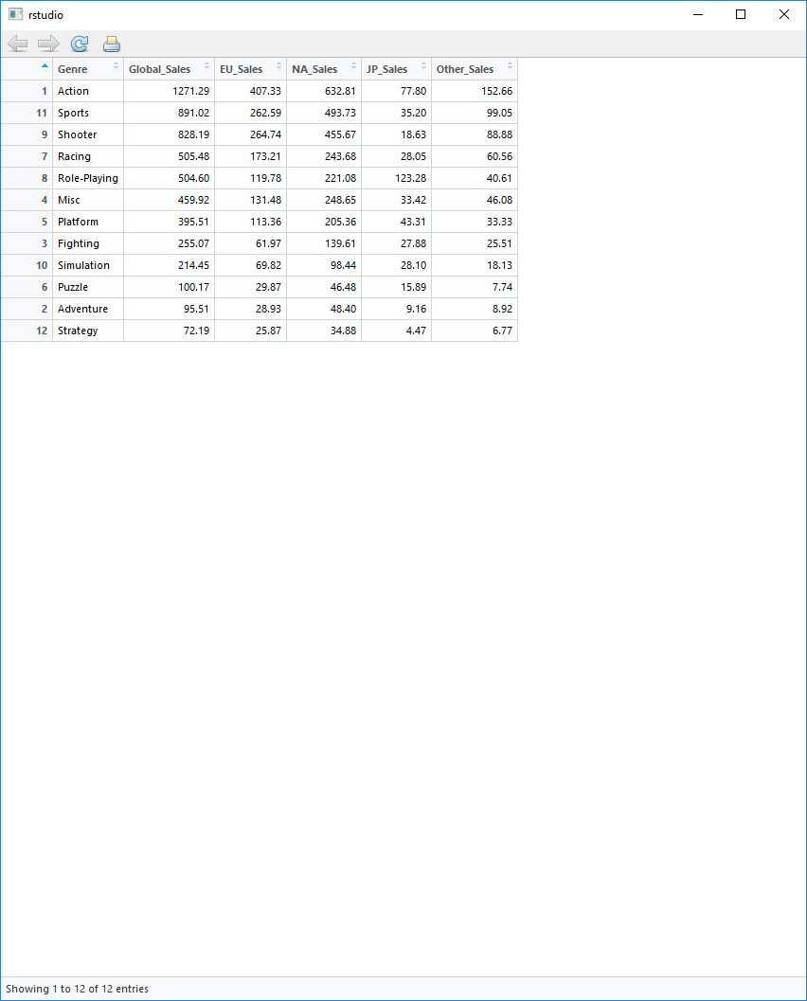

Based on the above, the 3 most popular genres are Action, Sports, and Shooter. The categories can be a bit too generalized and ambiguous since not all action or shooting games are graphic and violent. It all depends on the context and content.

Here are the means of all sales separated by their Ratings and sorted by the mean of Global Sales.

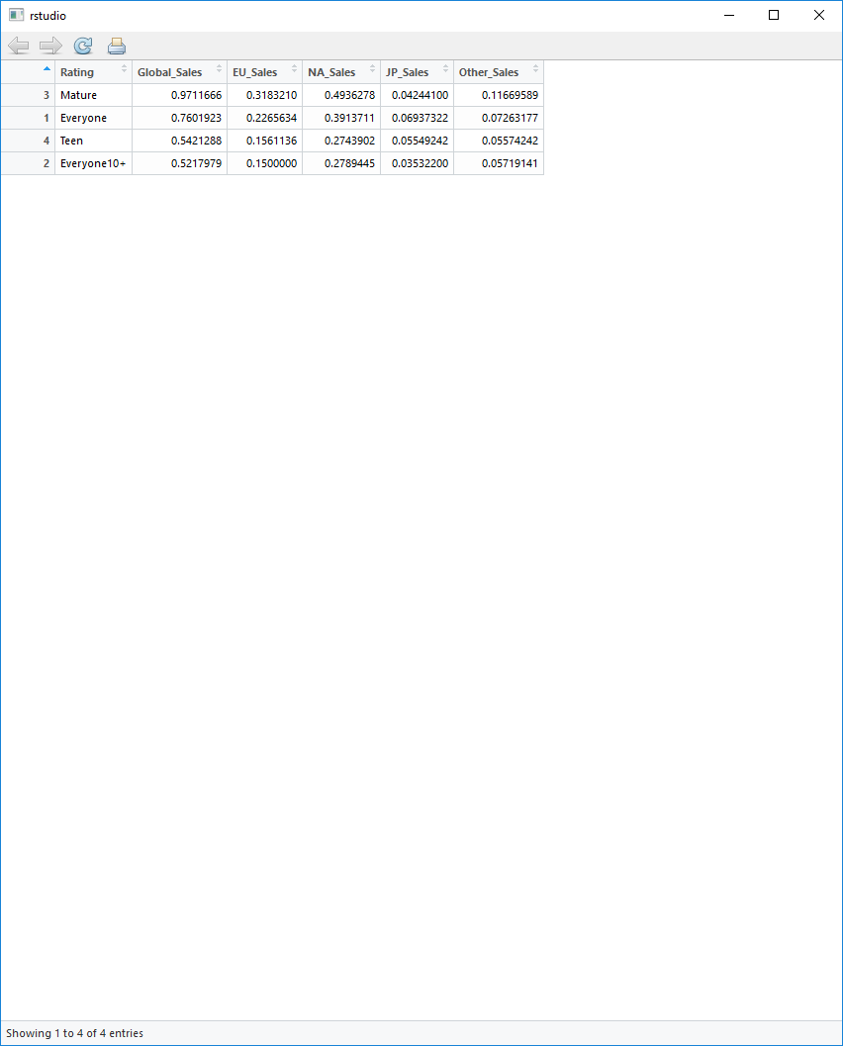

We removed Adults Only/KidsToAdults/RatingPending games since there were very few results in these categories. Therefore, Mature rated games appear to have sold on average the most out of all of them apart from Japan. Visualization of the above is shown in the bar plots below.

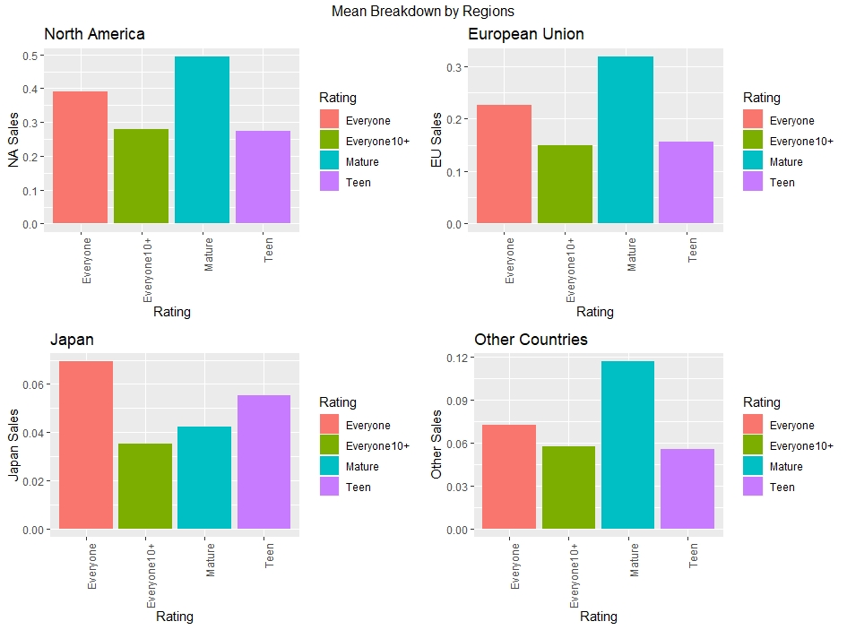Now let’s look at Critic Score. As per Metacritic, they define game scores into 3 groups; ‘good’ (75-100), ‘average’ (50-74), and ‘bad’ (0-49). ( Link - <https://www.metacritic.com/about-metascores> ) Therefore, we will add a new column with the score rating and visualize the distribution.

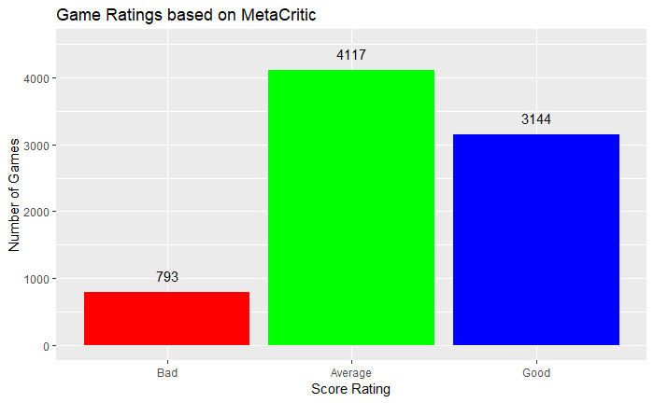

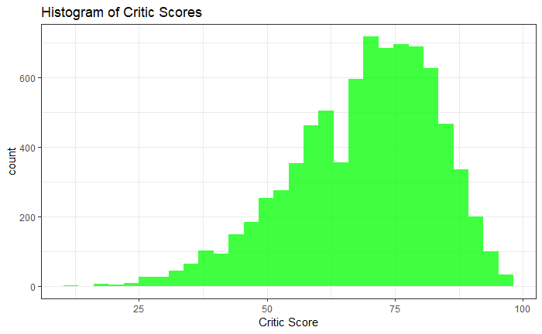

The game ratings under the 3 groups are skewed to the left and is further illustrated in the histogram of the Critic Scores where the concentration of scores lies between 70 to 85.

Are there any correlation between Critic Score and Sales? As per the last row in the below correlation matrix, there are little to no correlation towards all regions.

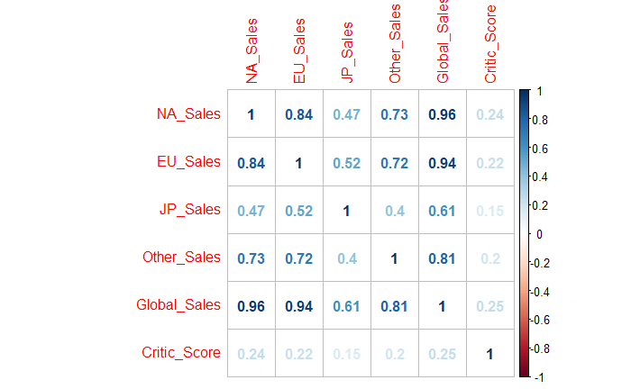

**cor.test(GamesCleaned2$Critic_Score, GamesCleaned2$Global_Sales)**

**cor.test(GamesCleaned2b$User_Score, GamesCleaned2b$Global_Sales)**

Pearson's product-moment correlation

data: GamesCleaned2$Critic_Score and GamesCleaned2$Global_Sales

t = 22.78, df = 8052, p-value < 2.2e-16

alternative hypothesis: true correlation is not equal to 0

95 percent confidence interval:

0.2254342 0.2664708

sample estimates:

cor

0.2460628

Pearson's product-moment correlation

data: GamesCleaned2b$User_Score and GamesCleaned2b$Global_Sales

t = 7.41, df = 6945, p-value = 1.412e-13

alternative hypothesis: true correlation is not equal to 0

95 percent confidence interval:

0.06518734 0.11185058

sample estimates:

cor

0.08856755

**CriticScore_Sales <- lm(data = GamesCleaned2, Global_Sales ~ Critic_Score)**

**summary(CriticScore_Sales)**

**UserScore_Sales <- lm(data = GamesCleaned2b, Global_Sales ~ User_Score)**

**summary(UserScore_Sales)**

Call:

lm(formula = Global_Sales ~ Critic_Score, data = GamesCleaned2)

Residuals:

Min 1Q Median 3Q Max

-1.460 -0.618 -0.286 0.156 81.609

Coefficients:

Estimate Std. Error t value Pr(>|t|)

(Intercept) -1.525499 0.099425 -15.34 <2e-16 ***

Critic_Score 0.032187 0.001413 22.78 <2e-16 ***

---

Signif. codes: 0 ‘***’ 0.001 ‘**’ 0.01 ‘*’ 0.05 ‘.’ 0.1 ‘ ’ 1

Residual standard error: 1.769 on 8052 degrees of freedom

Multiple R-squared: 0.06055, Adjusted R-squared: 0.06043

F-statistic: 518.9 on 1 and 8052 DF, p-value: < 2.2e-16

Call:

lm(formula = Global_Sales ~ User_Score, data = GamesCleaned2b)

Residuals:

Min 1Q Median 3Q Max

-1.040 -0.657 -0.415 -0.005 81.659

Coefficients:

Estimate Std. Error t value Pr(>|t|)

(Intercept) -0.08675 0.11835 -0.733 0.464

User_Score 0.11970 0.01615 7.410 1.41e-13 ***

---

Signif. codes: 0 ‘***’ 0.001 ‘**’ 0.01 ‘*’ 0.05 ‘.’ 0.1 ‘ ’ 1

Residual standard error: 1.941 on 6945 degrees of freedom

Multiple R-squared: 0.007844, Adjusted R-squared: 0.007701

F-statistic: 54.91 on 1 and 6945 DF, p-value: 1.412e-13

Both the above linear models exhibit low p-values which means critic scores and user scores are statistically significant with respect to global sales. Even though there is a correlation between the two scores, it doesn’t seem to be linear with a lot of outliers. See the below charts where I have omitted ‘Adults Only/KidsToAdults/RatingPending’ games due to their low counts.

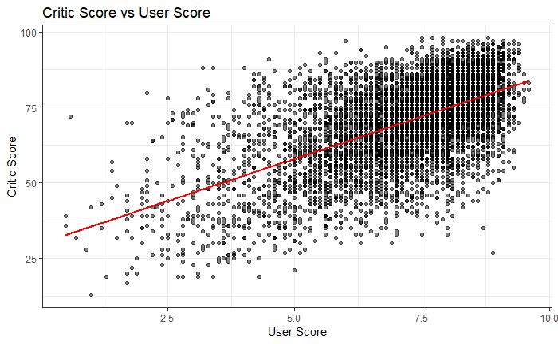

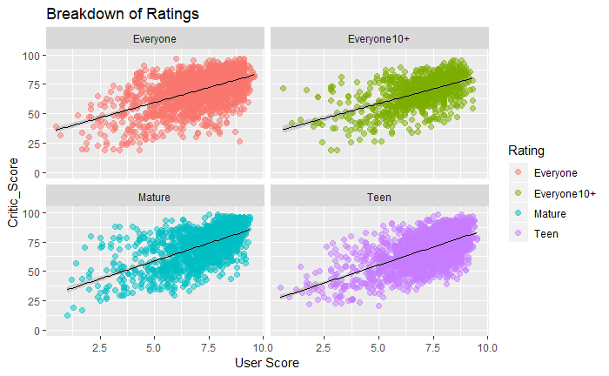

The below 2 charts have been cleaned of outliers to better show the relationship between critic and user score with respect to global sales. You can see that the effect of critic score is more consistent and has a higher impact on global sales compared to user scores.

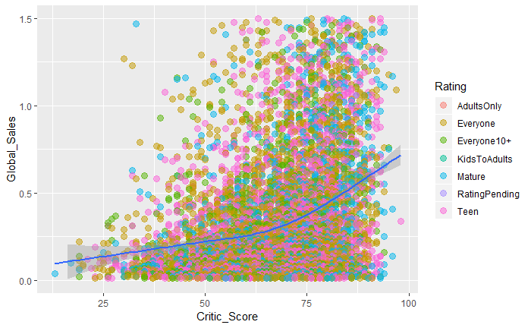

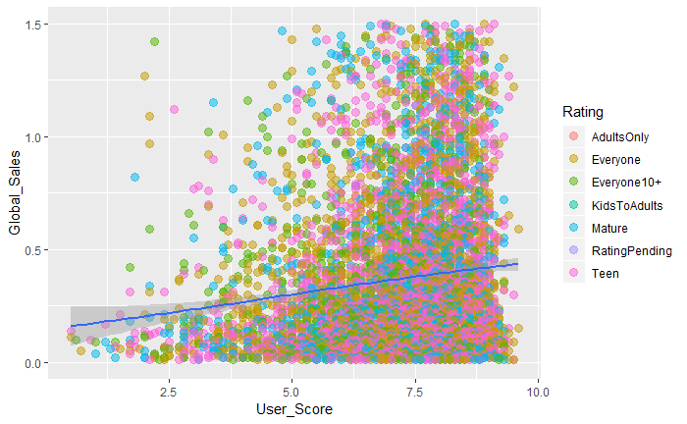

**Conclusion**

Sales of all games seems to show similarities across all regions of the world. It is evident that there has been an increase in market share for sales of higher rated games in the last two decades, but it doesn’t necessarily mean they particularly sold better compared with lower rated games. Although ‘Mature’ rated games are being released more and more, ‘Everyone’ rated games still have sold the most overall, but the gap is closing. There’s also another caveat where the legitimacy of how the ESRB rates games can be debated. Some say there are a lot of games that are not properly rated as the definition of violence or inappropriate content vary from one person to another.

Despite the many outliers in the dataset, critic scores for the most part has a greater impact on sales compared with rating, which makes sense since gamers tend to usually buy games after reading good reviews. This is also under the assumption of review scores being unbiased across all games. A lot of popular and big-name publishers may have an influence on reviewers who have loyalty towards certain companies.